**Emmet, headings and block vs inline**

1. Emmet is a plugin used in text-editors that helps speed up coding of HTML/XML. Emmet is installed in VSCode by default.
2. Some Emmet shortcuts are as follows:  
   a. h1>lorem2 + tab => <h1> lorem ipsum </h1>

b. p>lorem1 + tab => <p> lorem </p>

c. a + tab => <a href=””></a>

d. img + tab => <img src=”” alt=””>

in img tag , in src part we write “./” if the image is present in same folder, and we write “./location of folder” if the image is present in different folder.

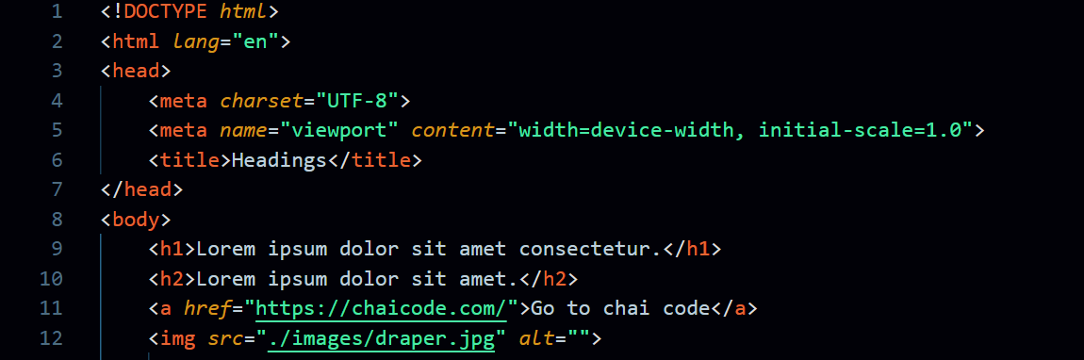

1. The entire content in line9, is an element.
2. <h1></h1> are tags. <h1> is start tag and </h1> is end tag.
3. Some elements/tags only have attributes, not all.
4. Attributes define the property of an element/tag.
5. Also, there are some attributes that can be used in all tags.

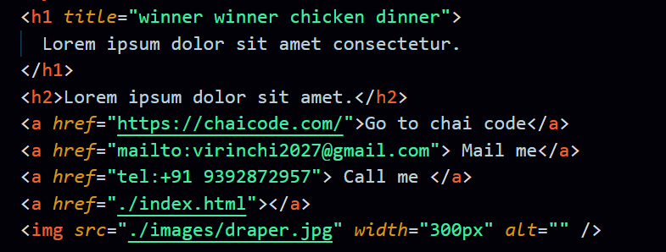

1. Anchor tag can also redirect us to the default mail client on your system with website’s contact mail. Syntax: href=”<mailto:name@mail.com>”
2. Anchor tag can also redirect us to a mobile’s call app with website’s contact number. Syntax: href=<tel:+91 9392872857>
3. In HTML, there are 2 types of elements, they are:  
   a. Block elements.

b. Inline elements.

1. Block elements: Elements that occupy/consume/claim the space from left to right.
2. Inline elements: These elements don’t claim the entire space. 